

Semester One Examination, 2021
Question/Answer booklet

MATHEMATICS
SPECIALIST
UNIT 3

SOLUTIONS
Section Two:
Calculator-assumed
WA student number: In figures

In words

Your name
Number of additional
answer booklets used
(if applicable):

Time allowed for this section
Reading time before commencing work: ten minutes
Working time: one hundred minutes

Materials required/recommended for this section
To be provided by the supervisor
This Question/Answer booklet
Formula sheet (retained from Section One)

To be provided by the candidate
Standard items: pens (blue/black preferred), pencils (including coloured), sharpener,
correction fluid/tape, eraser, ruler, highlighters

Special items: drawing instruments, templates, notes on two unfolded sheets of A4 paper, and up to three calculators, which can include scientific, graphic and Computer Algebra System (CAS) calculators, are permitted in this ATAR course examination

Important note to candidates
No other items may be taken into the examination room. It is your responsibility to ensure that you do not have any unauthorised material. If you have any unauthorised material with you, hand it to the supervisor before reading any further.

Structure of this paper

Section | Number of  questions  available | Number of  questions to  be answered | Working  time  (minutes) | Marks  available | Percentage  of  examination
Section One:  Calculator-free | 8 | 8 | 50 | 50 | 35
Section Two:  Calculator-assumed | 13 | 13 | 100 | 90 | 65
 |  |  |  | Total | 100

Instructions to candidates

1. The rules for the conduct of examinations are detailed in the school handbook. Sitting this examination implies that you agree to abide by these rules.

2. Write your answers in this Question/Answer booklet preferably using a blue/black pen.
Do not use erasable or gel pens.

3. You must be careful to confine your answers to the specific question asked and to follow any instructions that are specific to a particular question.

4. Show all your working clearly. Your working should be in sufficient detail to allow your answers to be checked readily and for marks to be awarded for reasoning. Incorrect answers given without supporting reasoning cannot be allocated any marks. For any question or part question worth more than two marks, valid working or justification is required to receive full marks. If you repeat any question, ensure that you cancel the answer you do not wish to have marked.

5. It is recommended that you do not use pencil, except in diagrams.

6. Supplementary pages for planning/continuing your answers to questions are provided at the end of this Question/Answer booklet. If you use these pages to continue an answer, indicate at the original answer where the answer is continued, i.e. give the page number.

7. The Formula sheet is not to be handed in with your Question/Answer booklet.
Section Two: Calculator-assumed 65% (90 Marks)
This section has thirteen questions. Answer all questions. Write your answers in the spaces provided.

Working time: 100 minutes.

Question 9 (6 marks)
The graph of $f(x)=\begin{matrix}a(b-x^{2}) \\ \overline{(x-c)(x+d)}\end{matrix}$ is shown below, where $a, b, c$ and $d$ are positive constants.

The dotted lines are the asymptotes of the function.
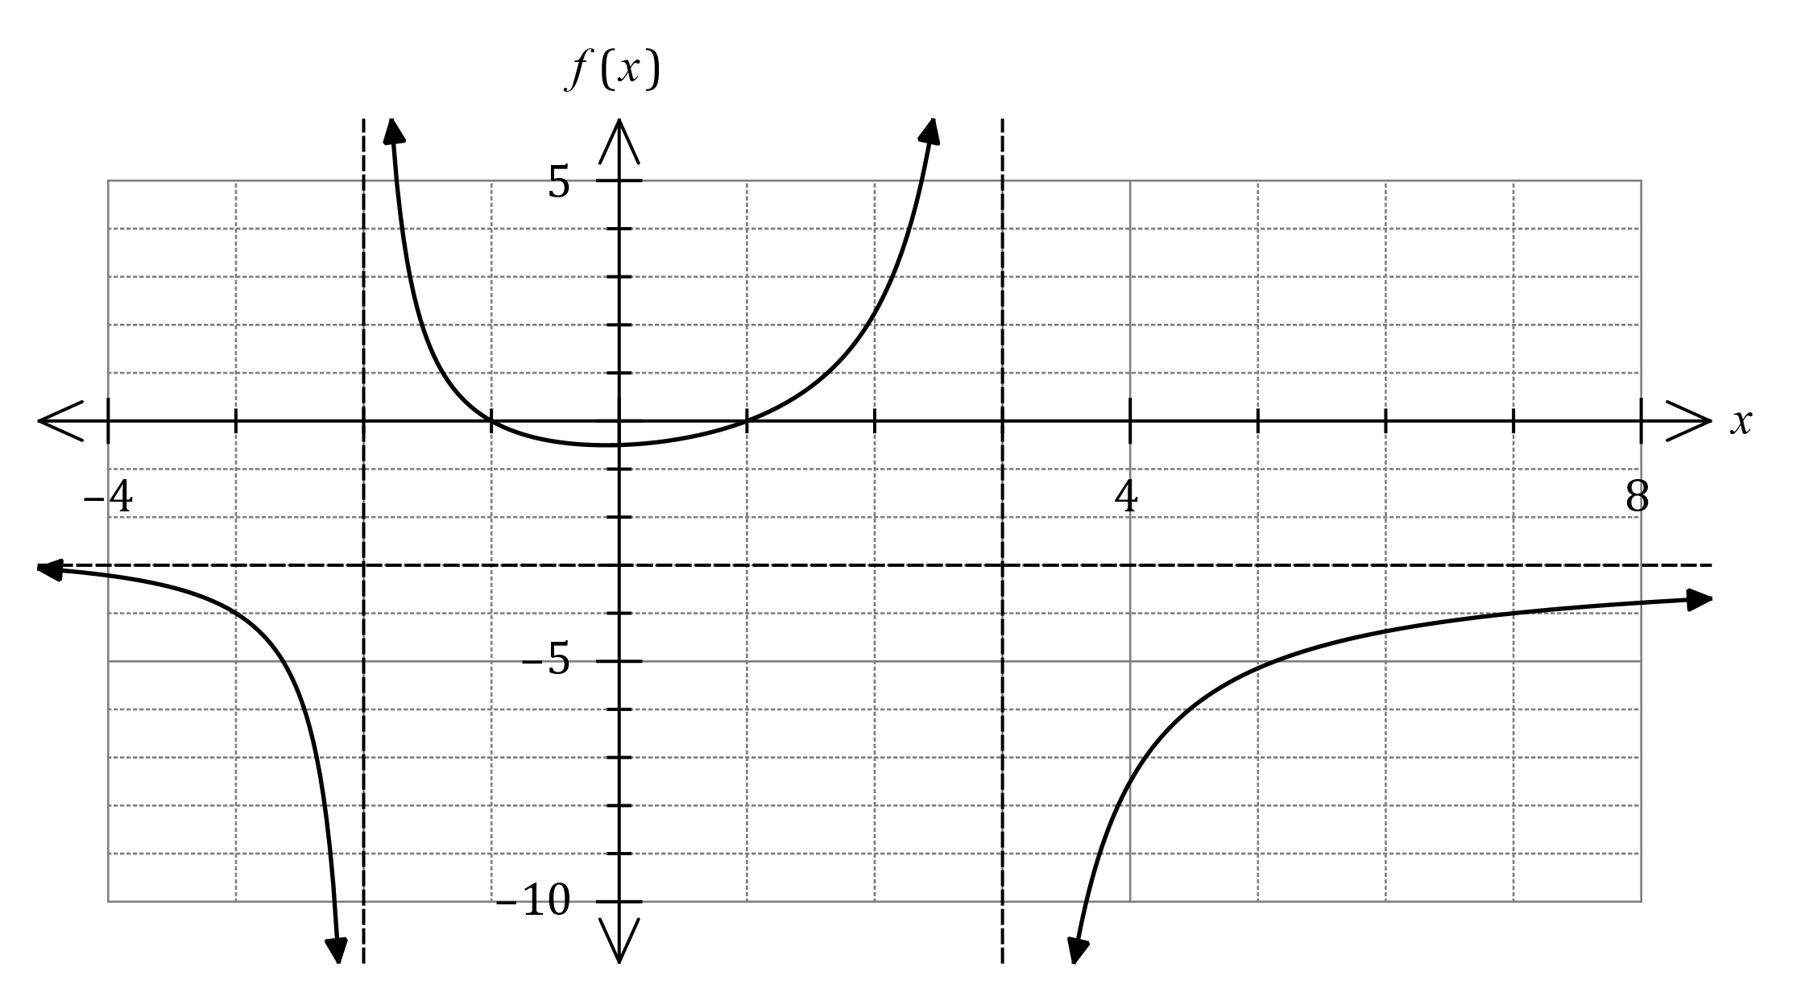

(a) Determine and write the value of each constant in the table below. (4 marks)
Solution
Pole at $x=-2⇒d=2$
Pole at $x=3⇒c=3$
Roots at $x=±1⇒b=1$
Asymptote $y=-3⇒a=3$

Specific behaviours
each constant

Constant | $$a$$ | $$b$$ | $$c$$ | $$d$$
Value | $$3$$ | $$1$$ | $$3$$ | $$2$$

(b) State the equations of all asymptotes of the graph of $y=\begin{matrix}1 \\ \overline{f(x)}\end{matrix}$ . (2 marks)
Solution
Roots become vertical asymptotes:
$$x=-1, x=1$$
Horizontal asymptote:
$$y=-\frac{1}{3}$$

Specific behaviours
both vertical asymptotes
ü horizontal asymptote

Question 10 (7 marks)
The arguments of the non-zero complex numbers $u$ and $v$ are $θ$ and $ϕ$ respectively, and the modulus of $u$ is twice the modulus of $v$.

Express the following in simplest form.

(a) $|u÷v|$. (1 mark)
Solution
$$\left|u\right|÷\left|v\right|=2\left|v\right|÷\left|v\right|=2$$

Specific behaviours
simplifies correctly

(b) $\arg\left(iu\right)+\arg{(\overline{u})}$. (2 marks)
Solution
$$\arg{(i)}+\arg{(u)}-\arg\left(u\right)=\frac{π}{2}$$

Specific behaviours
indicates one correct simplification
ü simplifies correctly

(c) $\begin{matrix}v\overline{v} \\ \overline{|iu|}\end{matrix}$. (2 marks)
Solution
$$\frac{{\left|v\right|}^{2}}{\left|i\right|\left|u\right|}=\frac{{\left|v\right|}^{2}}{1×2\left|v\right|}=\frac{1}{2}|v|$$

Specific behaviours
indicates two correct simplifications
ü simplifies correctly

(d) $\arg\left(\begin{matrix}\overline{uv} \\ \overline{3u^{2}}\end{matrix}\right)$. (2 marks)
Solution
$$-arg{(u)}-\arg\left(v\right)-2arg\left(u\right)=-3θ-ϕ$$

Specific behaviours
indicates two correct simplifications
ü simplifies correctly

Question 11 (5 marks)
The velocity vector of a particle at time $t$ seconds is given by $v\left(t\right)=\left(\begin{matrix}2t-8 \\ 5 \\ 3e^{0.5t}\end{matrix}\right)$ metres. The initial position vector of the particle is $18i+10j+2k$.

(a) Determine the displacement vector $r(t)$ for the particle after $t$ seconds. (3 marks)
Solution
$$r\left(t\right)=\int{v\left(t\right)}dt \\ =\left(\begin{matrix}t^{2}-8t \\ 5t \\ 6e^{0.5t}\end{matrix}\right)+c$$

$$r\left(0\right)=\left(\begin{matrix}0 \\ 0 \\ 6\end{matrix}\right)+c=\left(\begin{matrix}18 \\ 10 \\ 2\end{matrix}\right)⇒c=\left(\begin{matrix}18 \\ 10 \\ -4\end{matrix}\right)$$

$$r(t)=\left(\begin{matrix}t^{2}-8t+18 \\ 5t+10 \\ 6e^{0.5t}-4\end{matrix}\right)$$

Specific behaviours
indicates need for integral of velocity vector
ü correctly integrates components
ü evaluates constant and writes displacement vector

(b) Determine the minimum distance of the particle from the $y$-$z$ plane. (2 marks)
Solution
Require $i$-component to be minimum:

$$t^{2}-8t+18={\left(t-4\right)}^{2}+2$$

Hence minimum distance from $y$-$z$ plane is $2$ m.

Specific behaviours
indicates $i$-component to be minimum
ü correct minimum distance

Question 12 (8 marks)
(a) The locus of a complex number $z$ is the circular region shown below.

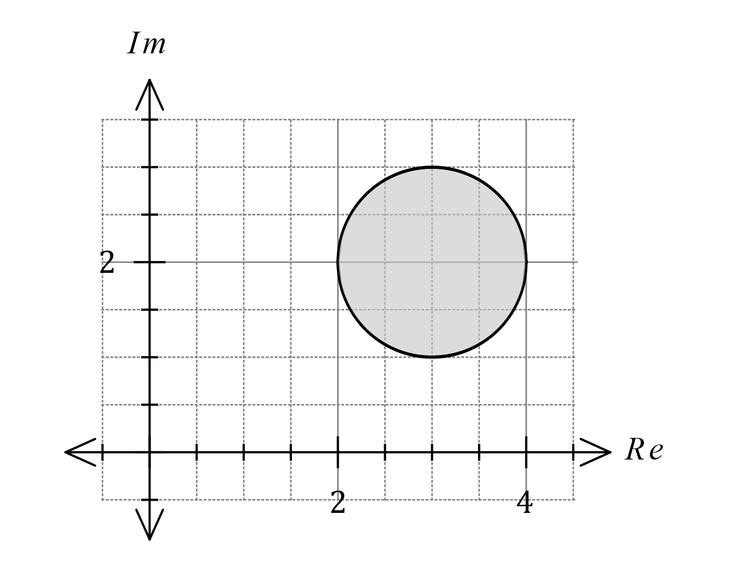

(i) Write equations or inequalities in terms of $z$ (without using $\operatorname{Re}{(z)}$ or $\operatorname{Im}\left(z\right)$) for the indicated locus. (3 marks)

Solution
$$\left|z-\left(3+2i\right)\right|≤1$$

Specific behaviours
forms an inequality using modulus
ü uses a difference between $z$ and circle centre
ü uses correct radius on RHS

(ii) Determine the minimum value for $|z-3i|$ as an exact value. (2 marks)

Solution
Let line from $A$ (at $3i$) to circle centre $O$ intersect the circle at $P$.

$$|OA|=\sqrt{3^{2}+1^{2}}=\sqrt{10}$$

$$\left|AP\right|=\left|OA\right|-r \\ =\sqrt{10}-1$$

Specific behaviours
indicates how minimum occurs
ü calculates correct exact minimum

(b) On the complex plane below sketch the locus of the complex number $z$ determined by
$-\begin{matrix}π \\ \overline{4}\end{matrix}<\arg\left(z+4-2i\right)≤\begin{matrix}π \\ \overline{4}\end{matrix}$. (3 marks)

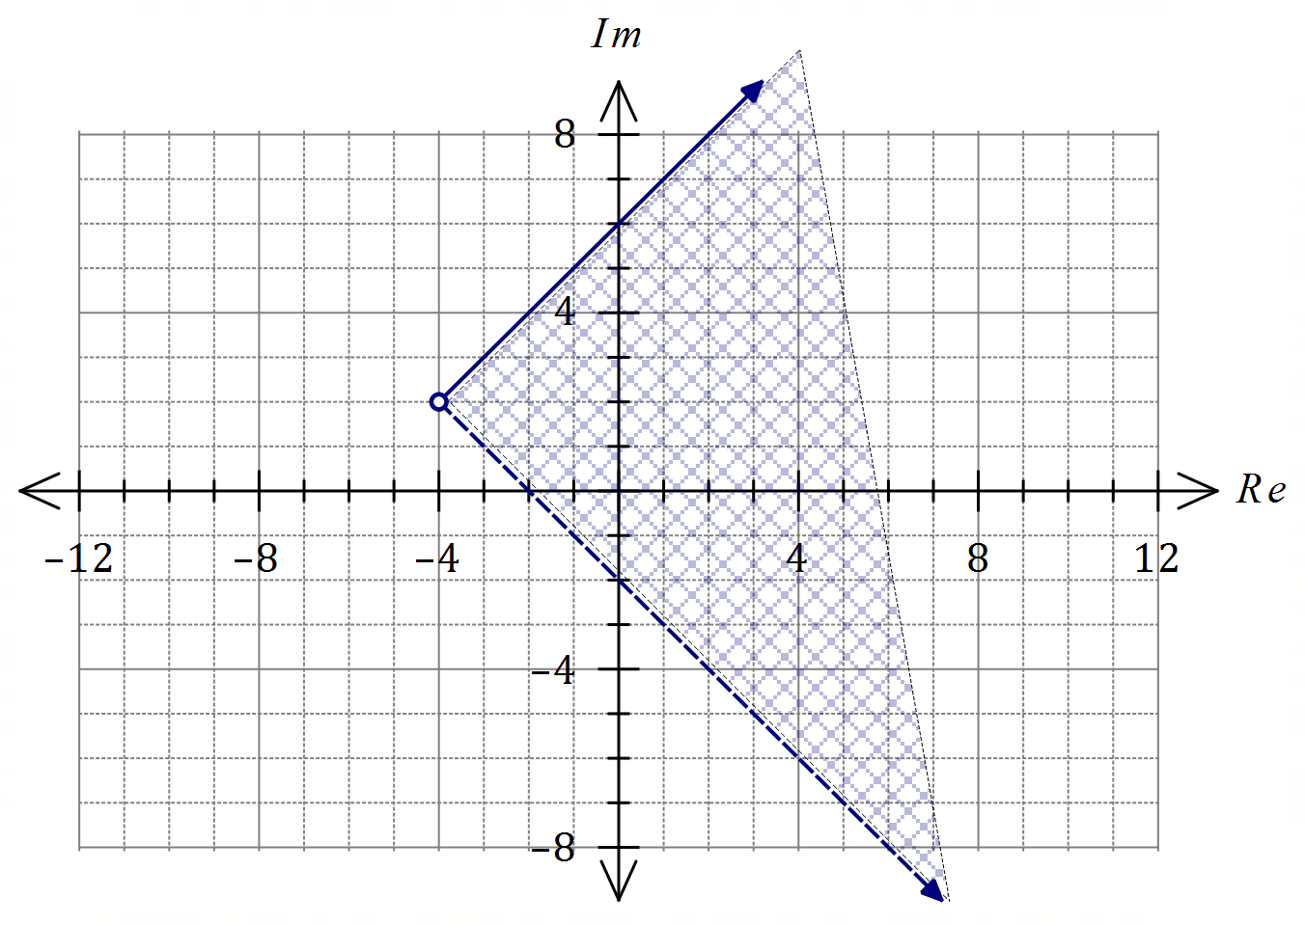
Solution
See graph (allow filled point for start of ray)
Specific behaviours
uses correct translation from origin for start of rays
ü lower ray dashed and angled correctly
ü upper ray solid, angled correctly; correct shading

Question 13 (7 marks)
Functions $f$ and $g$ are defined as $f\left(x\right)=\begin{matrix}1 \\ \overline{\sqrt{x+1}}\end{matrix}$ and $g\left(x\right)=e^{x^{2}-1}$.

(a) State the domain of $f(x)$ and explain why $f$ has an inverse. (2 marks)
Solution
$$D_{f}=\{x:x∈R, x>-1\}$$

$f$ has an inverse as it is a one-to-one function.

Specific behaviours
correct domain
ü states $f$ is one-to-one

(b) Determine the defining rule for $f^{-1}(x)$ and state its range. (2 marks)
Solution
$$x=\frac{1}{\sqrt{y+1}}→y+1=\frac{1}{x^{2}}→f^{-1}\left(x\right)=\frac{1}{x^{2}}-1$$

$$R_{f^{-1}}=D_{f}=\{y:y∈R, y>-1\}$$

Specific behaviours
correct defining rule
ü correct range

(c) Determine the defining rule for $g\left(f\left(x\right)\right)$ and state its domain and range. (3 marks)
Solution
$$g\left(f\left(x\right)\right)=e^{\frac{1}{x+1}-1}$$

Domain: $\{x:x∈R, x>-1\}$

Range: As $x→-1^{+}, g\left(f\left(x\right)\right)→∞$ and as $x→∞, g\left(f\left(x\right)\right)→e^{-1}$

$$\left\{y:y∈R, y>\frac{1}{e} \right\}$$

Specific behaviours
simplified composite function
ü correct domain
ü correct range

Question 14 (7 marks)
The position vectors of the points $A$ and $B$ are $r_{A}=\left(\begin{matrix}5 \\ 2 \\ 3\end{matrix}\right)$ and $r_{B}=\left(\begin{matrix}1 \\ -4 \\ 5\end{matrix}\right)$.

(a) If line segment $AB$ is the diameter of sphere $S$, determine the vector equation of $S$.
(3 marks)
Solution
Centre of sphere:
$$\vec{OC}=\frac{1}{2}\left(r_{A}+r_{B}\right)=\left(\begin{matrix}3 \\ -1 \\ 4\end{matrix}\right)$$
Radius of sphere:
$$r=\left|\left(\begin{matrix}5 \\ 2 \\ 3\end{matrix}\right)-\left(\begin{matrix}3 \\ -1 \\ 4\end{matrix}\right)\right|=\sqrt{14}$$
Equation:
$$\left|r-\left(\begin{matrix}3 \\ -1 \\ 4\end{matrix}\right)\right|=\sqrt{14}$$

Specific behaviours
calculates position vector of centre
ü calculates radius
ü correct vector equation

Straight line $L$ intersects the surface of sphere $S$ at point $A$ and has equation $r=r_{A}+λ\left(\begin{matrix}1 \\ 2 \\ -1\end{matrix}\right)$.

(b) Determine the position vector of $C$, the other point of intersection of $L$ with $S$. (4 marks)
Solution
$$r=\left(\begin{matrix}5 \\ 2 \\ 3\end{matrix}\right)+λ\left(\begin{matrix}1 \\ 2 \\ -1\end{matrix}\right)$$
Substitute line into sphere:
$$\left|\left(\begin{matrix}5+λ \\ 2+2λ \\ 3-λ\end{matrix}\right)-\left(\begin{matrix}3 \\ -1 \\ 4\end{matrix}\right)\right|=\sqrt{14}$$
Simplify and solve:
$${\left(2+λ\right)}^{2}+{\left(3+2λ\right)}^{2}+{\left(-1-λ\right)}^{2}=14$$
$$6λ^{2}+18λ=0$$
$$λ=0, λ=-3$$
Other point, $C$:
$$r_{C}=\left(\begin{matrix}5 \\ 2 \\ 3\end{matrix}\right)-3\left(\begin{matrix}1 \\ 2 \\ -1\end{matrix}\right)=\left(\begin{matrix}2 \\ -4 \\ 6\end{matrix}\right)$$

Specific behaviours
substitutes line into sphere
ü simplifies equation to remove magnitude
ü solves for $λ$
ü correct position vector

Question 15 (7 marks)
(a) The graph of $y=f(x)$ is shown with a dotted line on the axes below.
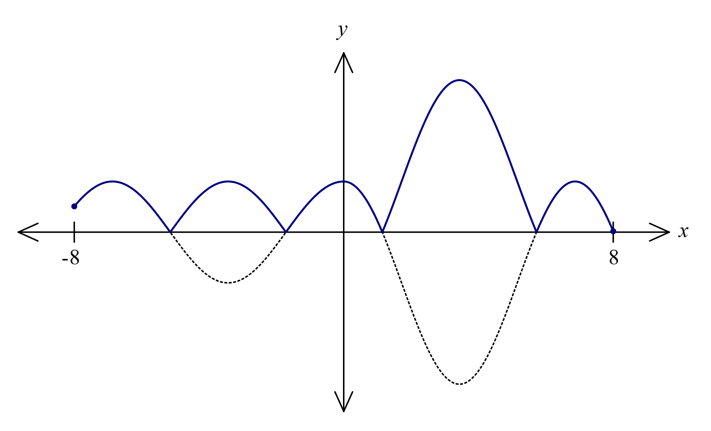
Solution
See graph - correct location and curvature
Specific behaviours
four concave down sections
ü section with $2$ inflection pts

(i) On the same axes, sketch the graph of $y=\left|f\left(x\right)\right|$. (2 marks)

(ii) State the number of roots that the graph $y=f\left(\left|x\right|\right)$ will have. (1 mark)
Solution
It will have $2×3=6$ roots.

Specific behaviours
ü correct number of roots

(b) The graph of $y=g(x)$ is shown with a dotted line on the axes below. Sketch the graph of $y=\begin{matrix}1 \\ \overline{g(x)}\end{matrix}$ on the same axes. (4 marks)
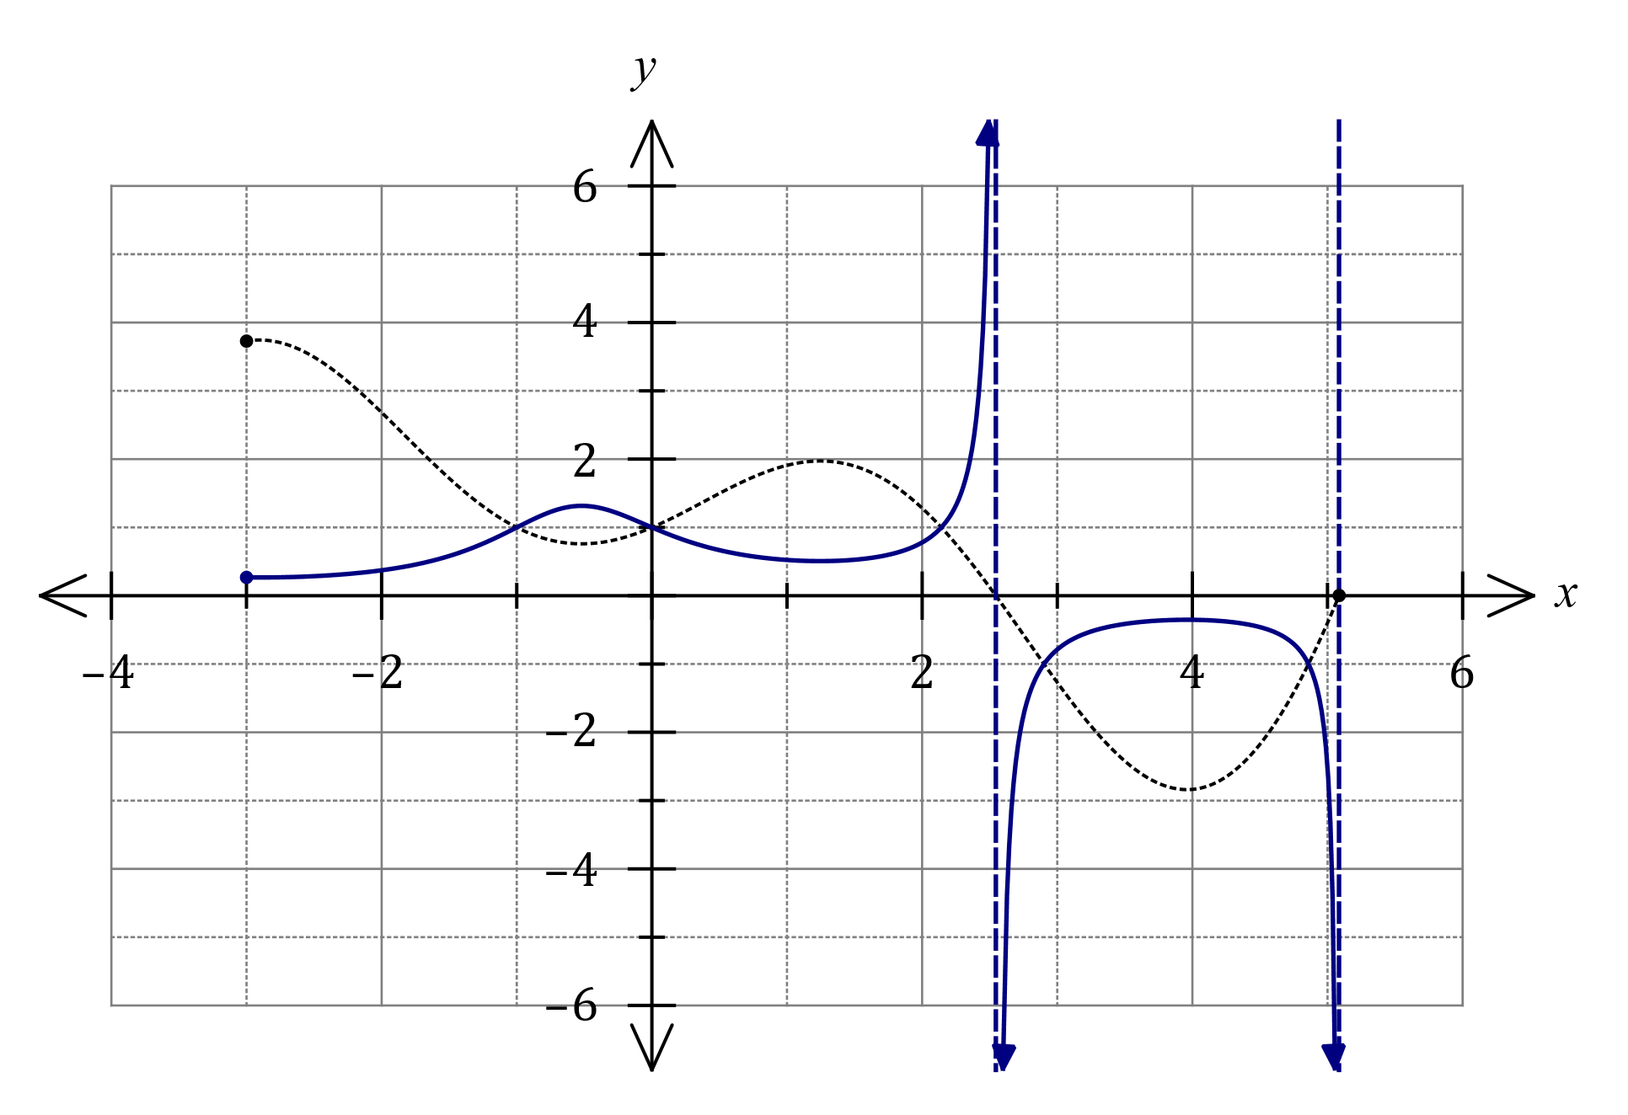
Solution
See graph - correct curvature and endpoints/asymptotes for each section.
Specific behaviours
section $-3≤x≤-1$
ü section $-1<x≤0$
ü section $x>0$ to asymptote
ü remaining section, below axis

Question 16 (8 marks)
(a) One solution to the equation $z^{3}=u$ is $z=2\operatorname{cis}{(-40°)}$.

(i) Determine the other two solutions, giving solutions in the form $r\operatorname{cis}{θ}$, where $r≥0$ and $-180°<θ≤180°$. (2 marks)
Solution
$$360°÷3=120°$$
$$z_{2}=2\operatorname{cis}{(-160°)}, z_{3}=2\operatorname{cis}{(80°)}$$

Specific behaviours
indicates angle separation of solutions
ü both solutions in required form

(ii) Determine $u$, giving your answer in the form $a+bi$. (2 marks)
Solution
$$u={\left(2\operatorname{cis}\left(-40°\right)\right)}^{3}$$
$$=8\operatorname{cis}\left(-120°\right) \\ =-4-4\sqrt{3}i$$

Specific behaviours
$u$ in polar form
ü $u$ in required form

(b) Solve the equation $z^{5}=16\sqrt{2}-16\sqrt{2}i$, giving exact solutions in the form $r\operatorname{cis}{θ}$, where $r≥0$ and $-π<θ≤π$. (4 marks)
Solution
$$z^{5}=16\sqrt{2}-16\sqrt{2}i \\ =32\operatorname{cis}\left(-\frac{π}{4}\right)$$
$$z_{k}=2\operatorname{cis}\left(-\frac{π}{20}+\frac{2kπ}{5}\right), k∈Z$$
$$z_{0}=2\operatorname{cis}\left(-\frac{π}{20}\right) \\ z_{1}=2\operatorname{cis}\left(\frac{7π}{20}\right) \\ z_{2}=2\operatorname{cis}\left(\frac{15π}{20}\right) \\ z_{3}=2\operatorname{cis}\left(-\frac{17π}{20}\right) \\ z_{4}=2\operatorname{cis}\left(-\frac{9π}{20}\right)$$

Specific behaviours
writes equation in polar form
ü indicates one correct root
ü indicates angle separation of roots
ü all roots in required form

Question 17 (8 marks)
Four points in space have coordinates $A\left(5, 4, -5\right), B\left(6, 3, -2\right), C(0, -1, 5)$ and $D(-3, 0, 1)$.

(a) Show that the lines $AC$ and $BD$ intersect and determine the coordinates of their point of intersection. (5 marks)
Solution
$$\vec{AC}=\left(\begin{matrix}0-5 \\ -1-4 \\ 5+5\end{matrix}\right)=\left(\begin{matrix}-5 \\ -5 \\ 10\end{matrix}\right), r_{A}=\left(\begin{matrix}5 \\ 4 \\ -5\end{matrix}\right)+t\left(\begin{matrix}-1 \\ -1 \\ 2\end{matrix}\right)$$

$$\vec{BD}=\left(\begin{matrix}-3-6 \\ 0-3 \\ 1+2\end{matrix}\right)=\left(\begin{matrix}-9 \\ -3 \\ 3\end{matrix}\right), r_{B}=\left(\begin{matrix}6 \\ 3 \\ -2\end{matrix}\right)+s\left(\begin{matrix}-3 \\ -1 \\ 1\end{matrix}\right)$$

Using $i, j$ coefficients:
$$5-t=6-3s \\ 4-t=3-s \\ s=1, t=2$$
Check with $k$ coefficients:
$$-5+4=-1 \text{and }-2+1=-1$$
Hence solution consistent with all three coefficients and so lines intersect at a point:
$${\left.\left(\begin{matrix}6 \\ 3 \\ -2\end{matrix}\right)+s\left(\begin{matrix}-3 \\ -1 \\ 1\end{matrix}\right)\right|}_{s=1}=\left(\begin{matrix}3 \\ 2 \\ -1\end{matrix}\right)$$
Point of intersection is at $(3, 2, -1)$.

Specific behaviours
equation for one line
ü equation for second line
ü writes set of simultaneous equations and solves for $s$ and $t$
ü checks for consistency and infers intersection
ü calculates point of intersection

(b) Determine the Cartesian equation of the plane containing the four points. (3 marks)
Solution
Directions of lines in plane: $\left(\begin{matrix}1 \\ 1 \\ -2\end{matrix}\right)$ and $\left(\begin{matrix}3 \\ 1 \\ -1\end{matrix}\right)$
Normal to plane:
$$\left(\begin{matrix}1 \\ 1 \\ -2\end{matrix}\right)×\left(\begin{matrix}3 \\ 1 \\ -1\end{matrix}\right)=\left(\begin{matrix}1 \\ -5 \\ -2\end{matrix}\right)$$
Hence equation is
$$x-5y-2z=\left(\begin{matrix}1 \\ -5 \\ -2\end{matrix}\right)∙\left(\begin{matrix}3 \\ 2 \\ -1\end{matrix}\right)=-5$$

Specific behaviours
ü indicates two vectors in plane
ü obtains normal to plane
ü states equation of plane

Question 18 (6 marks)
(a) The graph of $y=\left|f\left(x\right)\right|$ is shown below, where $f\left(x\right)=ax^{3}+bx^{2}+cx-9$. Determine the value of each of the coefficients $a, b$ and $c$. (3 marks)
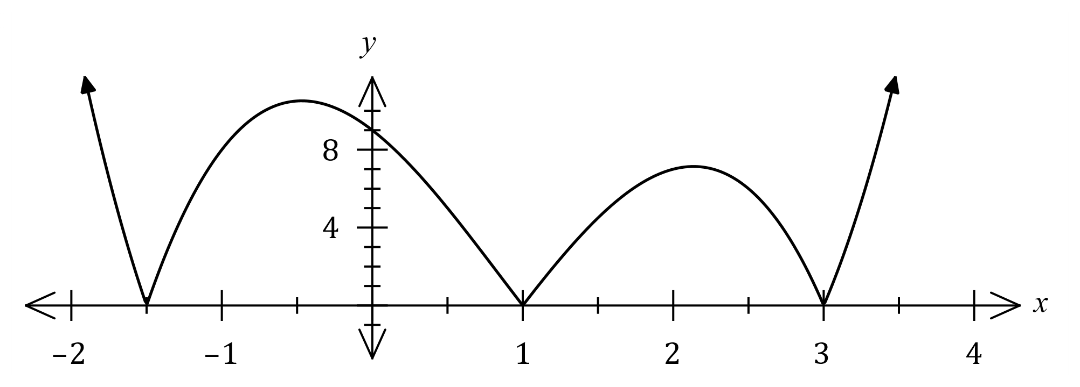
Solution
From roots, $f\left(x\right)=a\left(x+1.5\right)\left(x-1\right)\left(x-3\right)$.

From given function, $f\left(0\right)=-9⇒4.5a=-9⇒a=-2$.

$$f\left(x\right)=-\left(2x+3\right)\left(x^{2}-4x+3\right)=-\left(2x^{3}-5x^{2}-6x+9\right)$$

Hence $a=-2, b=5$ and $c=6$.

Specific behaviours
uses roots to obtain factored form of $f(x)$ with constant $a$
ü correct value of $a$
ü correct values of $b$ and $c$

(b) The graph of $y=\left|px\right|+\left|x+q\right|+r$ is shown below, where $p, q$ and $r$ are constants.
(3 marks)
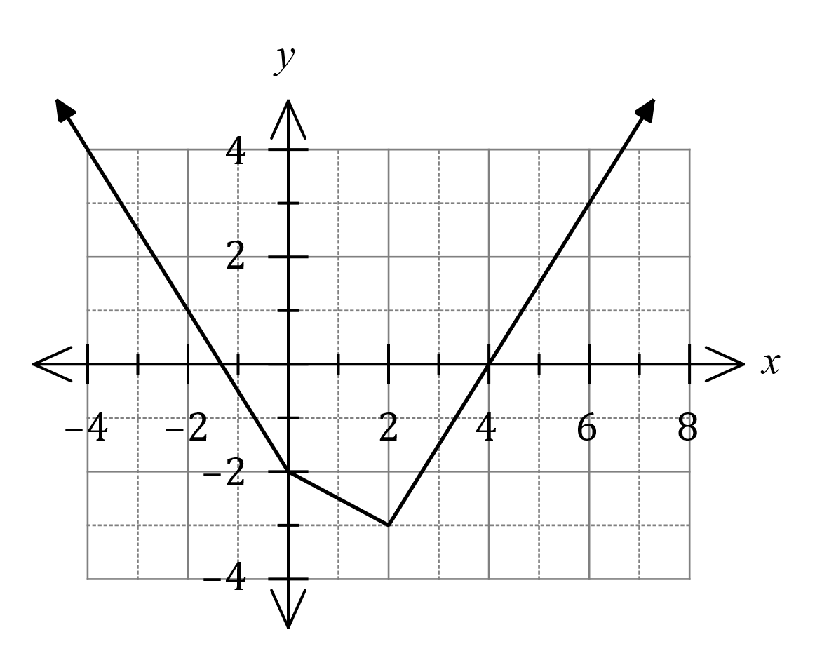

- Describe how the graph above indicates that the gradient of $\left|px\right|$ changes at $x=0$.

- Determine $p, q$ and $r$.

Question 19 (8 marks)
The position vector of a particle at time $t$ seconds is given by $r\left(t\right)=\left(\begin{matrix}5 \sin^{2}{(t)}-2 \\ 2\cos{t}\end{matrix}\right)$ cm.

The path of the particle is shown below, together with the points $A(-2, 2)$ and $B(3, 0)$ that lie on its path.
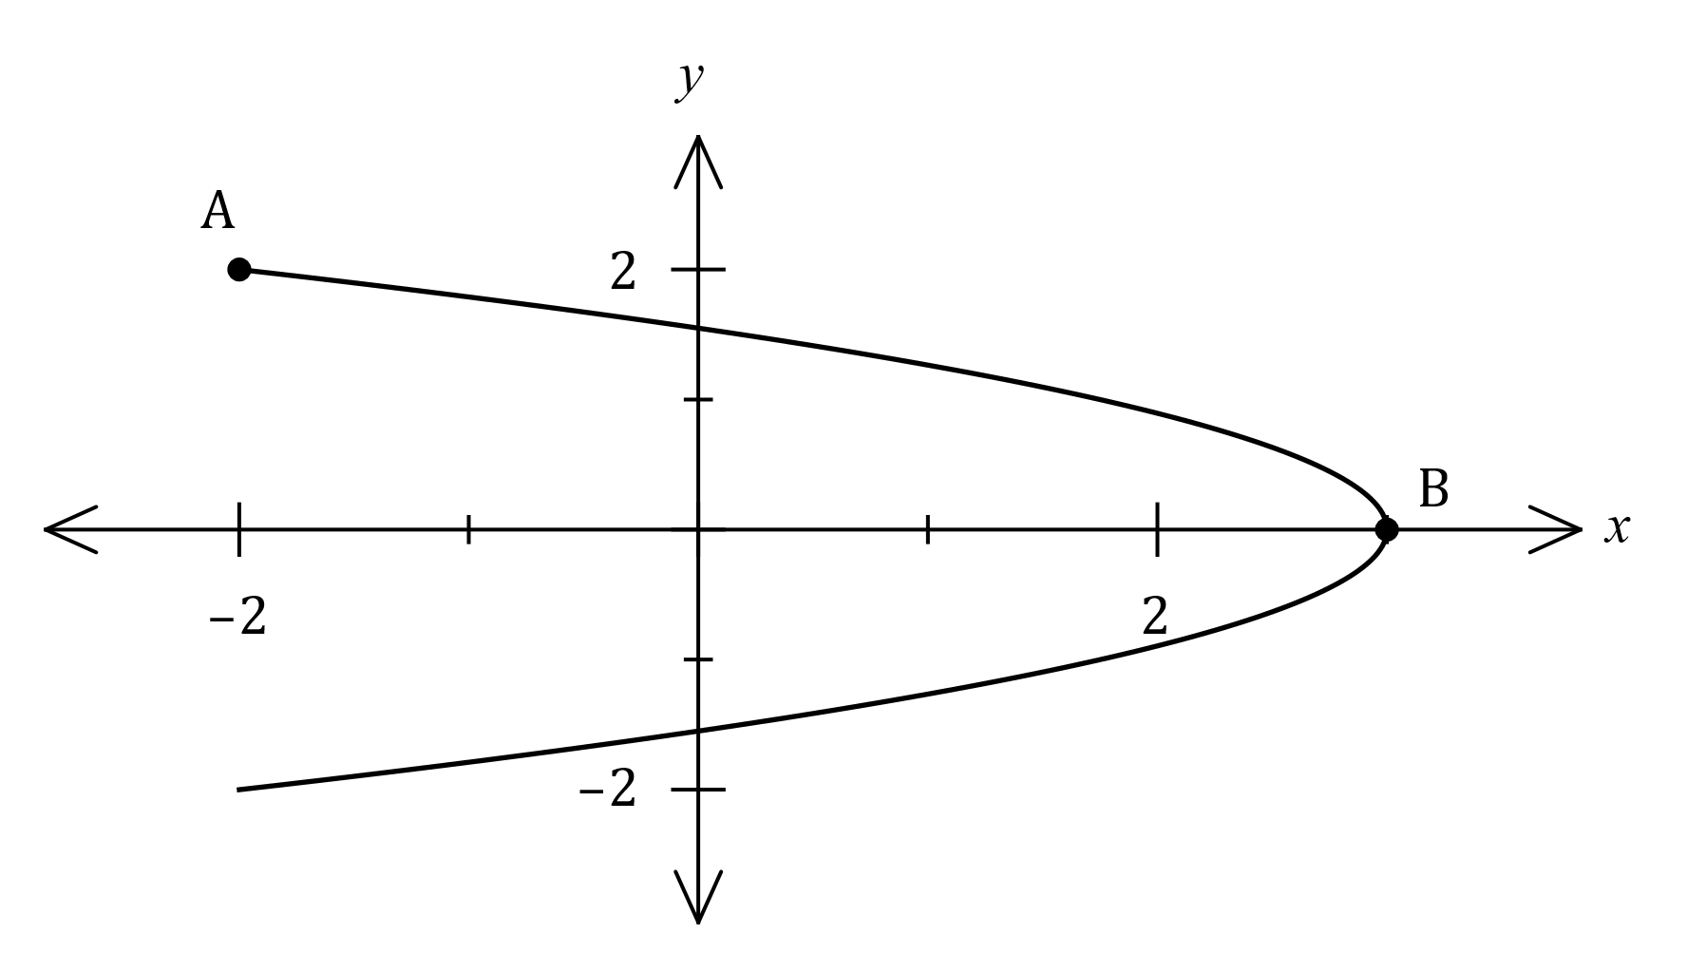

(a) Express the path of the particle as a Cartesian equation. (3 marks)
Solution
Note domain restriction: $-2≤x≤3$

$$\frac{x+2}{5}=\sin^{2}{t}, {\left( \frac{y}{2}\right)}^{2}=\cos^{2}{t}$$
Hence
$$\frac{x+2}{5}+\frac{y^{2}}{4}=1, -2≤x≤3$$

Specific behaviours
indicates use of Pythagorean identity to eliminate $t$
ü obtains Cartesian equation
ü includes domain or range restriction

(b) Determine the velocity of the particle when $t=\frac{π}{4}$. (2 marks)
Solution
$$v\left(t\right)=\left(\begin{matrix}10\cos{t}\sin{t} \\ -2\sin{t}\end{matrix}\right)$$

$$v\left(\frac{π}{4}\right)=\left(\begin{matrix}5 \\ -\sqrt{2}\end{matrix}\right)≈\left(\begin{matrix}5 \\ -1.41\end{matrix}\right)$$

Specific behaviours
ü obtains velocity vector
ü indicates velocity at given time

(c) Determine the distance travelled by the particle as it moves from $A$ to $B$. (3 marks)
Solution
Particle is at $A$ when $t=0$ and at $B$ when $t=\frac{π}{2}$.

$$d=\int_{0}^{\frac{π}{2}}{\left|v\left(t\right)\right|}dt \\ =\int_{0}^{\frac{π}{2}}{\sqrt{{\left(10\cos{t}\sin{t}\right)}^{2}+{\left(-2\sin{t}\right)}^{2}}}dt \\ =5.56 \text{cm}$$

Specific behaviours
indicates correct bounds for integral
ü indicates expression for speed
ü correct distance

Question 20 (6 marks)
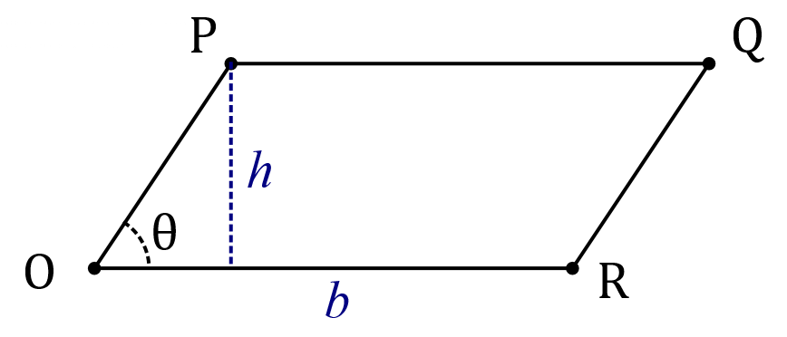
In the parallelogram shown, $\vec{OP}=p$,
$\vec{OR}=r$ and the angle between the
directions of $p$ and $r$ is $θ$.

It can be shown that $\left|p×r\right|=\left|p\right|\left|r\right|\sin{θ}$.

(a) Explain why evaluating $\left|p×r\right|$ will result in the area of the parallelogram. (2 marks)

Solution
Area is length of base ($\left|r\right|$) multiplied by perpendicular height ($\left|p\right|\sin{θ}$):

$$A=b×h=\left|r\right|×\left|p\right|\sin{θ}=\left|r×p\right|$$

Specific behaviours
relates one vector to base
ü relates other vector and angle to perpendicular height

The area of $OPQR$ is $3\sqrt{5}$ cm² when the position vectors of $O, P$ and $Q$ are $\left(\begin{matrix}0 \\ 0 \\ 0\end{matrix}\right), \left(\begin{matrix}a \\ -2 \\ 1\end{matrix}\right)$ and $\left(\begin{matrix}3 \\ -2 \\ -1\end{matrix}\right)$ respectively, with units in centimetres.

(b) Determine the value(s) of the constant $a$. (4 marks)
Solution
Determine $r$:
$$\vec{OR}=\vec{OQ}-\vec{OP} \\ =\left(\begin{matrix}3 \\ -2 \\ -1\end{matrix}\right)-\left(\begin{matrix}a \\ -2 \\ -1\end{matrix}\right)=\left(\begin{matrix}3-a \\ 0 \\ -2\end{matrix}\right)$$

Evaluate cross product (CAS):
$$p×r=\left(\begin{matrix}a \\ -2 \\ 1\end{matrix}\right)×\left(\begin{matrix}3-a \\ 0 \\ -2\end{matrix}\right)=\left(\begin{matrix}4 \\ 3+a \\ 6-2a\end{matrix}\right)$$

Magnitude of cross product (CAS):
$$\left|p×r\right|=\sqrt{5a^{2}-18a+61}$$

Equate to area and solve (CAS):
$$5a^{2}-18a+61=45 \\ a=2, a=\frac{8}{5}$$

Specific behaviours
vector for $r$
ü indicates cross product
ü indicates magnitude of cross product
ü equates to area and solves for correct values

Question 21 (7 marks)
Let the complex number $z=\sqrt{3}+i$ and the function $f$ be defind as $f\left(n\right)={(z)}^{n}-{(\overline{z})}^{n}, n∈Z$.

(a) Determine the modulus and argument of $f(-1)$. (2 marks)
Solution
$$f\left(-1\right)=-\frac{i}{2}=\frac{1}{2}\operatorname{cis}\left(-\frac{π}{2}\right)$$

Hence $\left|f\left(-1\right)\right|=\frac{1}{2}$ and $\arg\left(f\left(-1\right)\right)=-\frac{π}{2}$.

Specific behaviours
indicates correct $f(-1)$
ü clearly states both modulus and argument

(b) Use De Moivre's theorem to determine all values of $n$ for which $f\left(n\right)=0$. (5 marks)
Solution
$${\left(\sqrt{3}+i\right)}^{n}-{\left(\sqrt{3}-i\right)}^{n}=0 \\ {\left(2\operatorname{cis}\left(\frac{π}{6}\right)\right)}^{n}-{\left(2\operatorname{cis}\left(-\frac{π}{6}\right)\right)}^{n}=0 \\ 2^{n}\left(\operatorname{cis}\left(\frac{nπ}{6}\right)-\operatorname{cis}\left(-\frac{nπ}{6}\right)\right)=0 \\ \cos\left(\frac{nπ}{6}\right)+i\sin\left(\frac{nπ}{6}\right)-\cos\left(-\frac{nπ}{6}\right)-i\sin\left(-\frac{nπ}{6}\right)=0 \\ \cos\left(\frac{nπ}{6}\right)+i\sin\left(\frac{nπ}{6}\right)-\cos\left(\frac{nπ}{6}\right)+i\sin\left(\frac{nπ}{6}\right)=0 \\ 2i\sin\left(\frac{nπ}{6}\right)=0 \\ \sin\left(\frac{nπ}{6}\right)=0 \\ n=6k, k∈Z$$

Specific behaviours
equation in polar form
ü applies De Moivre's theorem
ü fully expands polar form, adjusting terms for positive arguments
ü simplifies to single term
ü states all possible values

Supplementary page

Question number: _________

Supplementary page

Question number: _________

© 2021 WA Exam Papers. Mandurah Catholic College has a non-exclusive licence to copy and communicate this document for non-commercial, educational use within the school. No other copying, communication or use is permitted without the express written permission of WA Exam Papers. SN192-174-4.

